# JS Advanced Final Exam

# Problem 1. Music Site

Link: <https://judge.softuni.org/Contests/Practice/Index/3235#0>

**Environment Specifics**

Please, be aware that every JS environment may **behave differently** when executing code. Certain things that work in the browser are not supported in **Node.js**, which is the environment used by **Judge**.

The following actions are **NOT** supported:

* **.forEach()** with **NodeList** (returned by **querySelector()** and **querySelectorAll()**)
* **.forEach()** with **HTMLCollection** (returned by **getElementsByClassName()** and **element.children**)
* Using the **spread-operator** (**...**) to convert a **NodeList** into an array
* **append()** in Judge (use only **appendChild()**)
* **replaceWith()** in Judge
* **replaceAll()** in Judge
* **closest()** in Judge
* **prepend()**
* **replaceChildren()**
* Always turn the collection into a **JS array** (forEach, forOf, et.)

If you want to perform these operations, you may use **Array.from()** to first convert the collection into an array.

**Use the provided skeleton to solve this problem.**

**Note**: You **can't** and you have no permission to **change** directly the given HTML code (index.html file).

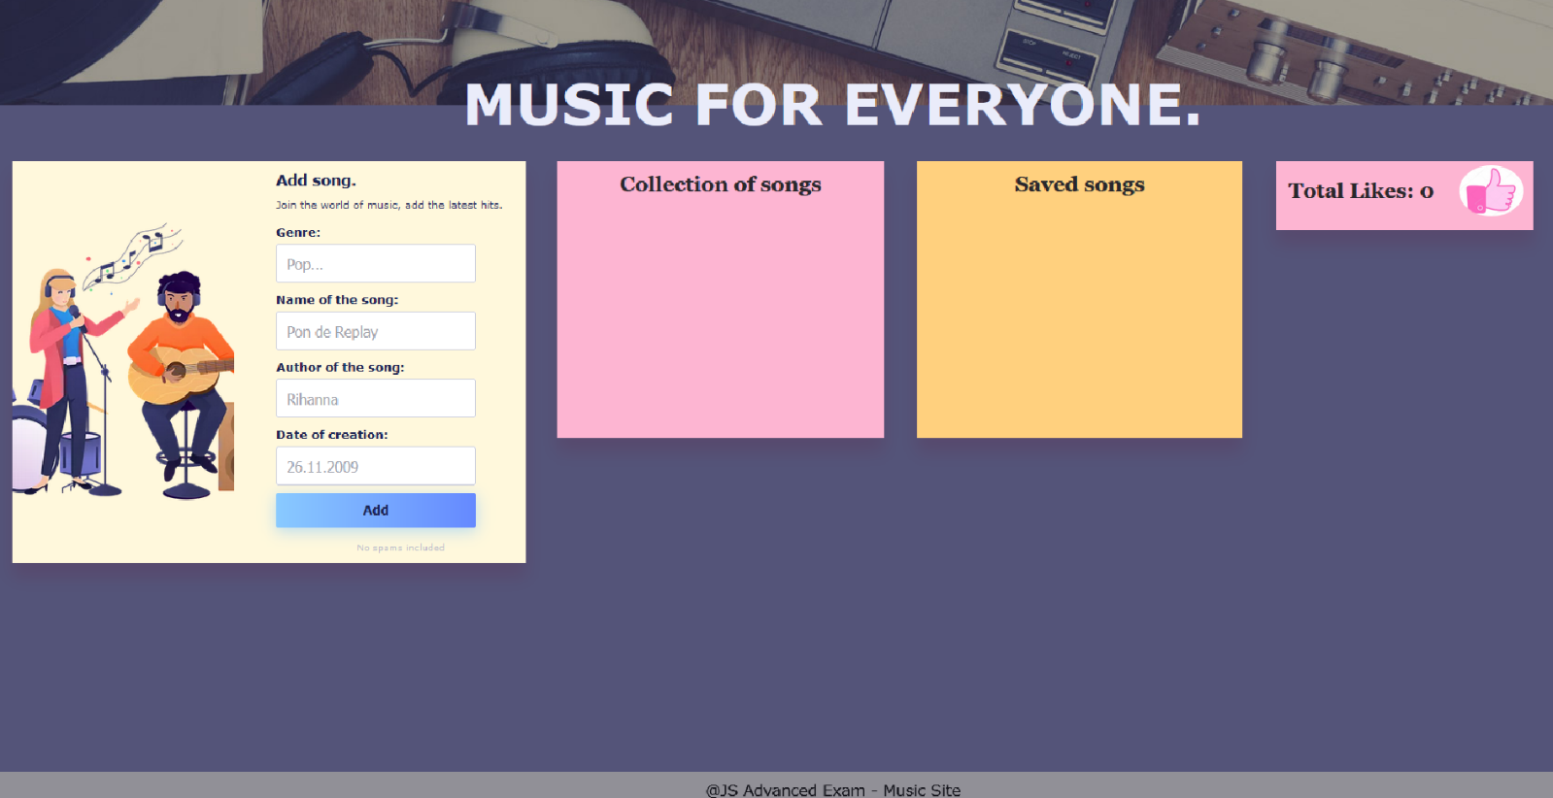

**Your Task**

**Write the missing JavaScript code** to make the **Music Site** work as expected:

* A**ll fields (genre, name, author, and date)** are **filled with the correct input**
  + **Genre, name, author, and date** are **non**-**empty** **strings**
* The program should not do anything if any of the input fields are empty.

1. 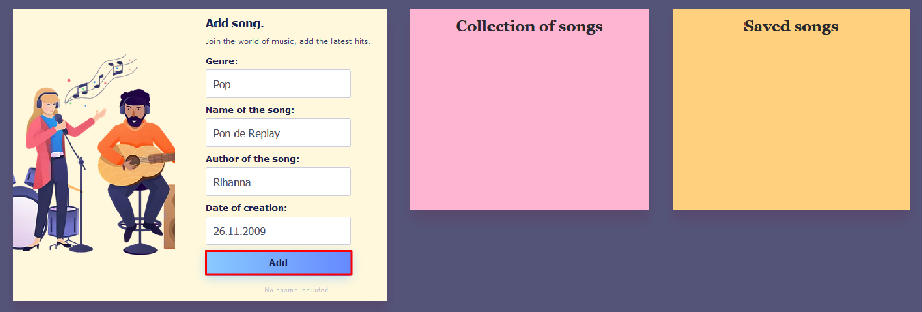**Getting the information about a new song**

* 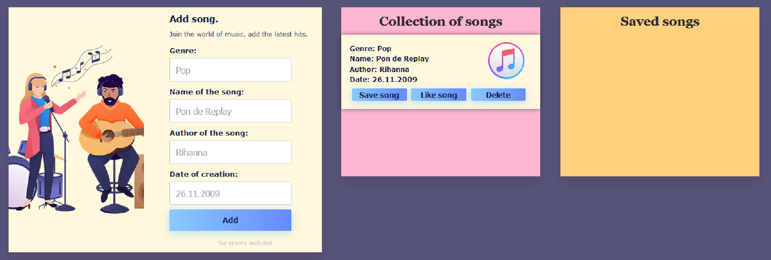When you click the **["**Add**"**] button, the information from the input fields must be added to the **div** with the **class** **"all-hits-container"** and then clear input fields.
* The HTML structure looks like this:

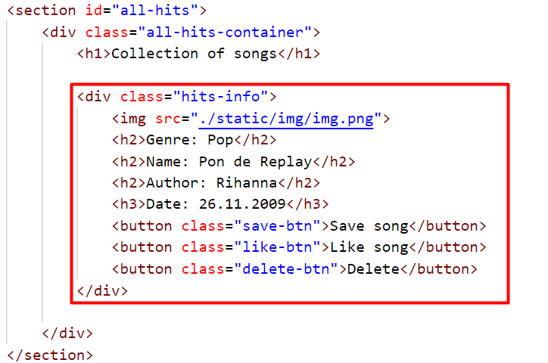

* 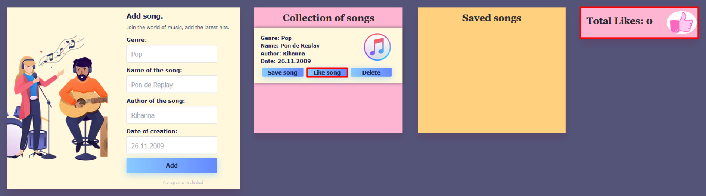When the **["**Like song**"**] button is clicked:
  + 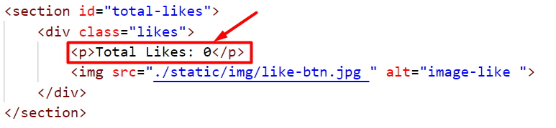You need to take a value of the current number of **likes** inside the paragraph in the section with the id **"total-likes"** and increase the value by one.
  + 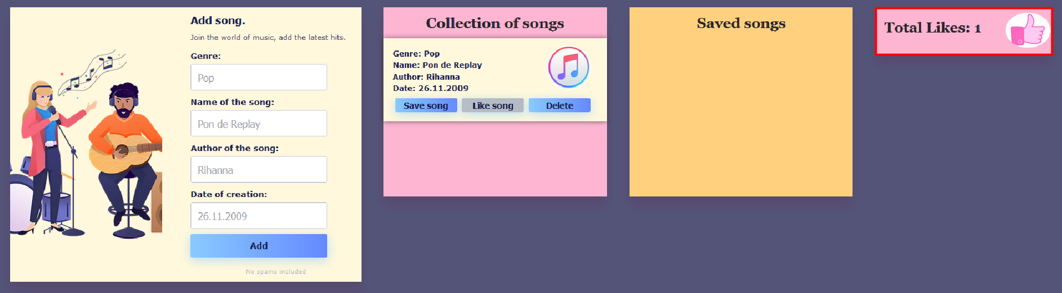The button **["**Like song**"**] for the current song must then be **disabled**, as the user has the right to like the song only once (Once the button is **disabled**, its color will turn gray).

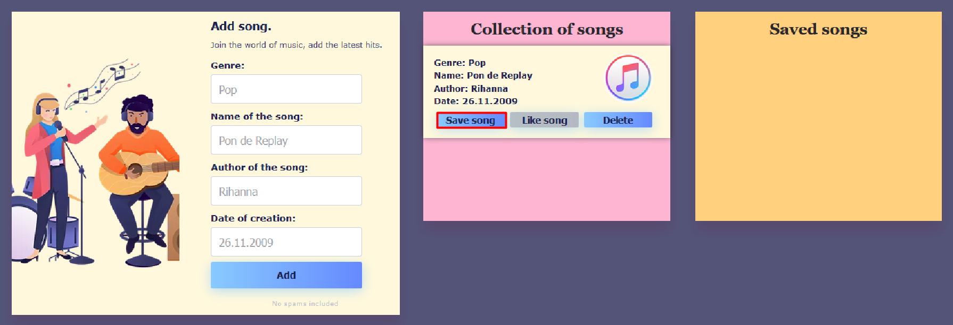

* 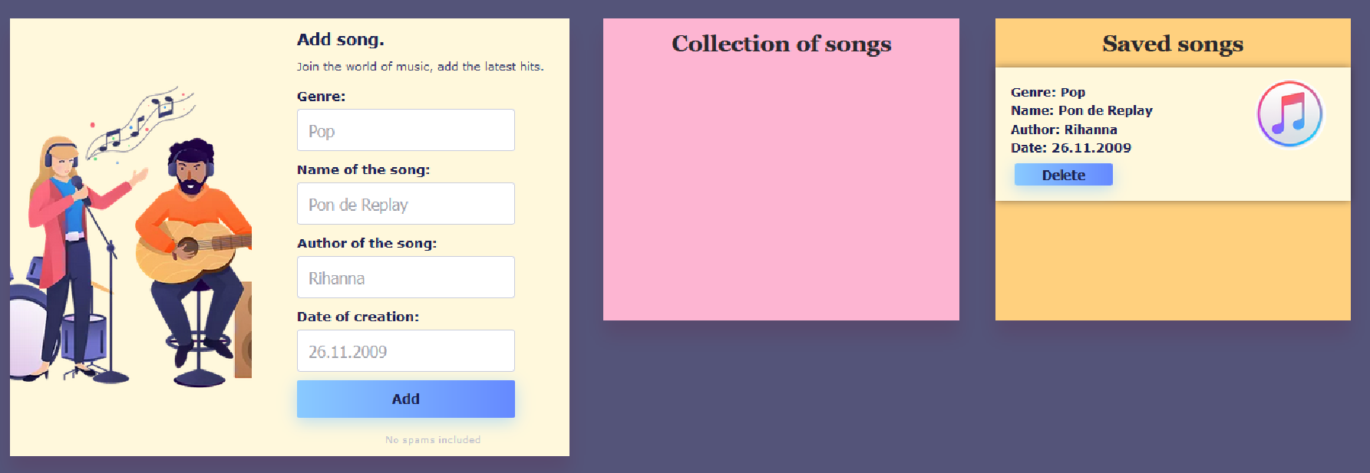When the **["**Save song**"**] button is clicked, you need to move the current song in the **div** with **class** **"saved-container"**.
* The HTML structure looks like this:

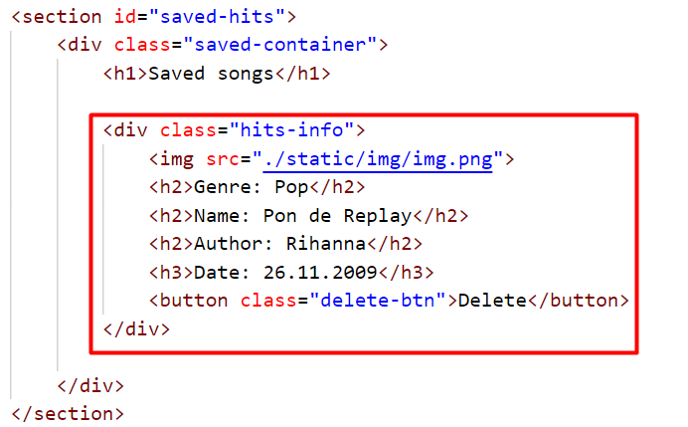

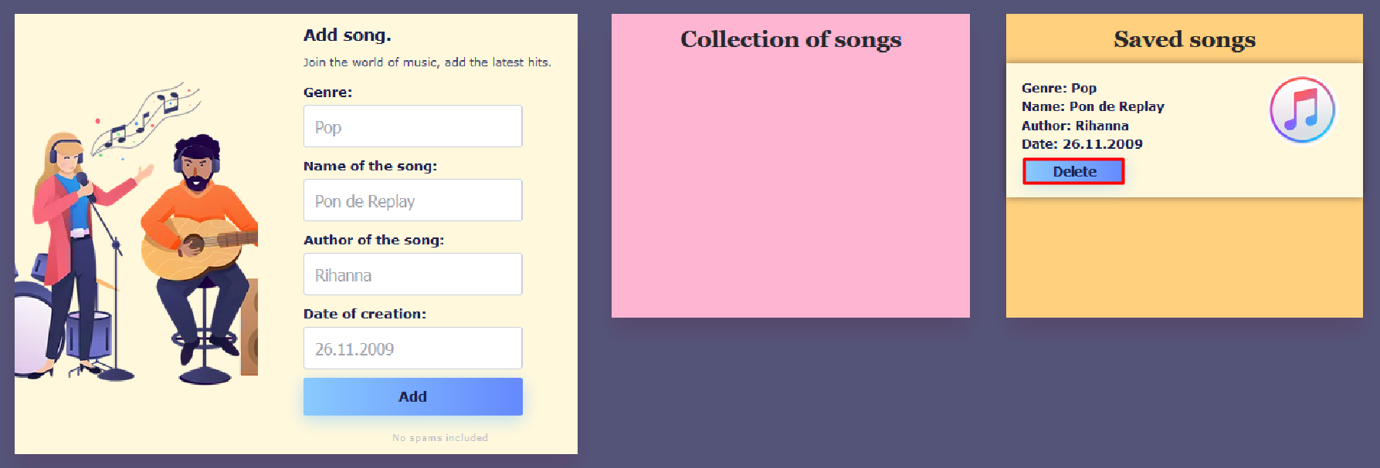

* When you click the **["**Delete**"**] button, the song should be removed from the current section.

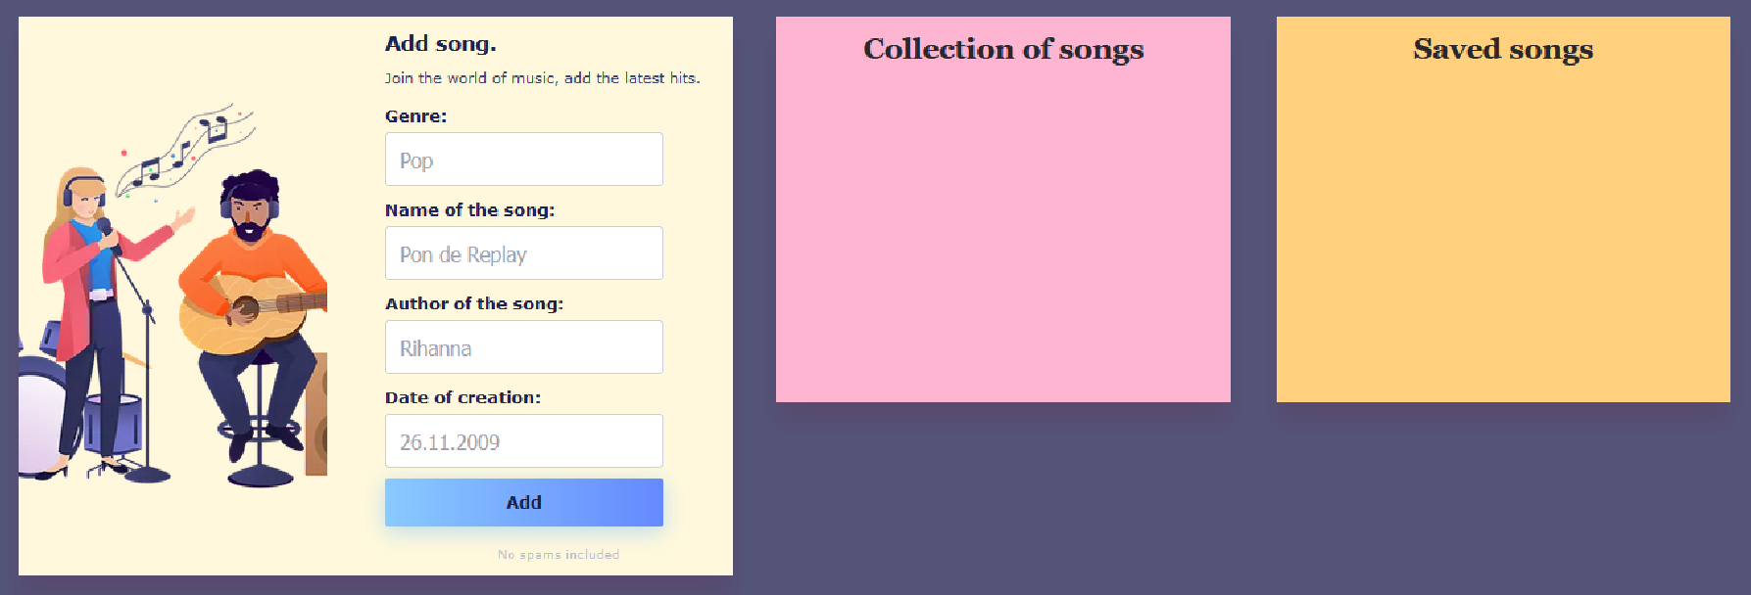**Note:** When deleting a song, you should not reduce the value of the current number of likes.

* 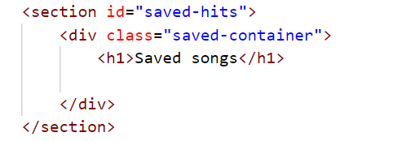The HTML structure looks like this:

**Submission**

Submit only your **solve()** function.

*GOOD LUCK… ☺*